
User Acceptance Testing (UAT) Template
Date | 27 January 2026
Team ID | LTVIP2026TMIDS28465
Project Name | ShopEZ : One-Stop Shop for Online Purchases
Maximum Marks | 4 Marks

Project Overview
Project Name: ShopEZ
- Project Description: ShopEZ is a full-stack e-commerce web application built using the MERN stack (MongoDB, Express.js, React.js, Node.js). It provides a seamless online shopping experience for users and a robust admin dashboard for sellers to manage inventory and orders2.
- Project Version: v1.0.0
- Testing Period: 19 February 2026
Testing Scope • Features and Functionalities to be Tested:
o User registration and login o Product browsing and filtering o Shopping cart management o Secure checkout and payment
flow o Order tracking o Admin inventory and management o
Responsive UI across devices

User Stories / Requirements to be Tested:
As a user, I want to register and log securely.
As a user, I want to browse and search for products.
As a user, I want to add/remove items from my cart.
As a user, I want to complete a purchase with safety.
As an admin, I want to manage product listings.

Testing Environment
• URL/Location: http://localhost:8080/api/products
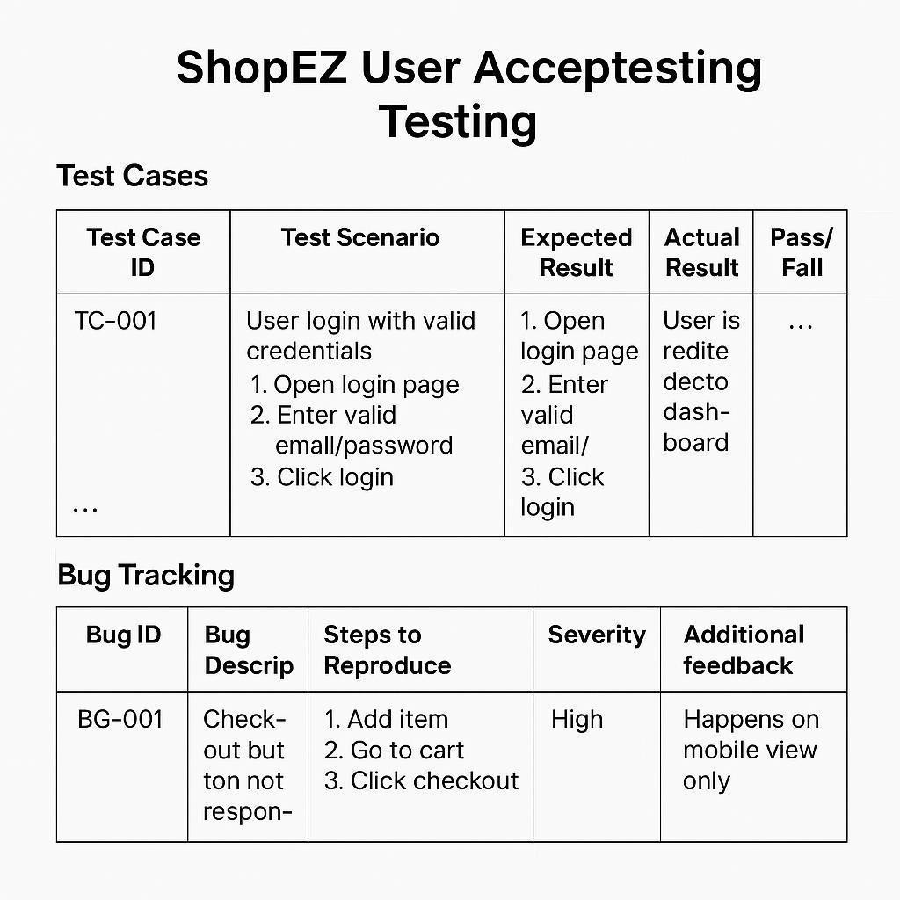

Sign-Off Details
- Tester Name: Damera Sai Sreeja
- Date of Test Completion: 19th February 2026
- Signature: _____Damera Sai Sreeja______________________

Final Notes
- All test cases have been executed, covering both positive and negative scenarios.
- Testers have provided detailed feedback, including usability suggestions and enhancement ideas.
- Bug tracking includes:
o Severity levels (Low, Medium, High, Critical) o
Status (Open, In Progress, Resolved, Closed) o
Clear steps to reproduce each issue
- All critical and high-severity bugs have been resolved or mitigated.
- Sign-off approval is required from:Project Manager,Product Owner

